Introduction

Clear explanation of the game that was selected

The game chosen is called Construct and Prosper and is a factory building type game, the game is similar in nature to Factorio and Satisfactory. You start out with a small number of supplies and must create buildings to automate the production of items and defend against enemy attacks.

The main difference this game has against similar games of the genre is that it doesn’t have conveyor belts for moving items around, instead you have citizens that do this, the advantage being that buildings can be set up more rapidly while still allowing for fine control of where items go. Another benefit is that the production of certain items can be easily prioritized over others allowing for a base that can quicky adapt to changing needs allowing the player to take a more active role in the base defence side of the game.

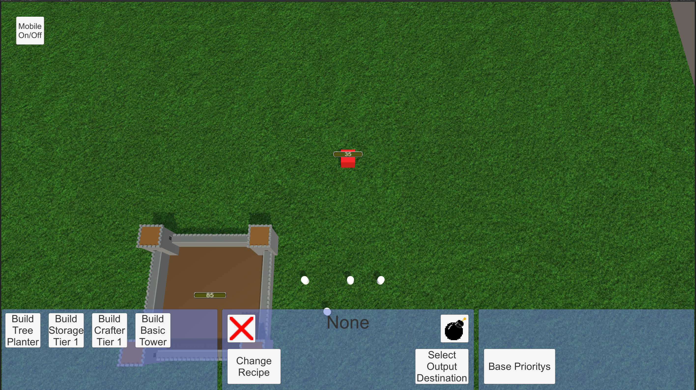

Clear description of the intended behaviour of the AI system

The main design goal was to have a group of agents that could efficiently use buildings to gather resources and craft items without much setup being required and while still being versatile, so all a player needs to do is place a few buildings, specify how materials are moved between buildings, select which materials are a priority and press update jobs. The game needed this as managing each agent one at a time would become tedious and would distract from the games more combat heavy gameplay.

Another design goal was optimization, I want the minimum possible resources per additional citizen added to the system as a base could potentially have hundreds of citizens moving about, doing jobs and I don’t want it to require a high end i9 to run.

Clear explanation of the techniques selected for use in developing the AI system for this game

I used a navmesh which is a built in AI tool in unity that facilitates movement of an agent object across a navmesh surface avoiding navmesh obstacles. This provides a simple but elegant way of implement an AI pathfinding system into a game.

This game uses a sort of finite state machine for its jobs as each job has a type which dictates how to ai behaves when it’s given it. Current jobs include, gather resource, the citizen works at the resource building and brings the output to the output destination, deliver resource, the citizen takes a resource from the building and delivers it to the output destination, and defence, the citizen enters the building and prepares to attack any enemy that enters range.

Justifiable description of why these techniques were selected

I am using a navmesh for the movement of the various AI, this was massively easier than implementing C\* or similar and works well for my game, as its not vital that an agent goes by the best possible route, its only crucial that the route be valid.

The job system or finite state machine was added because every job a citizen does in this game will fall into a few distinct categories with remarkably similar or identical behaviour. This allows for easier expandability as more buildings are added.

I used a building manager to selected jobs for the citizens as before they get swapping jobs with each other which would have become very inefficient in a large base.

Implementation

Clear description of the AI system architecture

The AI is split into two areas, the enemy AI and the citizen AI. The citizen AI works by having each citizen being assigned a job by the building manager. The building manager script gets the jobs by searching through a list of all available jobs, it does this in three passes. The first pass involves sorting the tasks by order of priority and returns a int value x from the following: tasks[tasks.Count - citizens.Count].priority; For the second pass, the task list is then searched though to find any tasks with a priority higher than X and adds then to enough list of tasks ready to be assigned. For the final pass, the remaining tasks need are found by searching though the list and add any task with a priority equal to x and stopping once tasksToBeAssigned.length equalled the citizens.length. Finally, each citizen gets a job from the tasksToBeWorked list if theirs is not already on it.

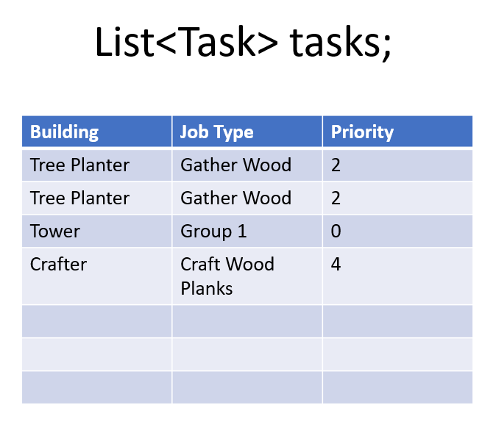

Once the citizen has a job, they move to the job site an begin working, once done they proceed to the output destination assigned on the building to drop of the collected resources. The only exception to this is if they have been assigned a tower job, in this case they go to the tower and stand on top and will fire at any enemies that come in range.

I went with a list of jobs so as for my game it’s very important that the right job/jobs get worked and that ideally continue to be worked unless the job has been removed or if the job priorities had been changed.

The enemy AI is yet to be fully implemented however, it is intended for them to attack the nearest building or citizen when within range and to move towards the players civilization in waves periodically. They will also attack anything that attacks them if they aren’t currently attacking anything or if their current target is further away.

Clear justification of major design decisions taken during the development of the AI system

Originally as I was developing the game, I had the citizens just move to the nearest building and perform that job, however this resulted in agents switching between jobs repeatedly, resulting in pointless moving around without achieving anything. I could have added a system of selecting the units and giving them tasks manually, however this approach meant that the player would have to manually implement every change in their behaviour manually which I felt wasn’t right for this game. I eventually went with the system I’m using currently where each citizen is assigned a job and it works far better, it is a more complex system that I would have liked but its simple to use with a lot of fine control and most importantly also allows for quick changing of resource production on the fly.

For the first implementation I searched though the tasks list once for each citizen for a job, this was a simple solution but it quicky became apparent that I needed a more clever solution because if I had to search though a 1000 item list 1000 times it could produce considerable lag, so I came up with a cleverer approach detailed above where the BuildingManager only needs to search though the list three times regardless of how many citizens exist.

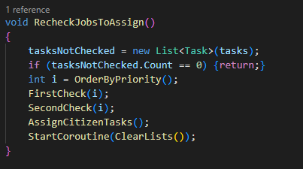Clear evidence of significant and complex artificial intelligence coding and development work

This is the master function of the code that handles which tasks are worked based on priority values, this calls the relevant functions to make things more manageable.

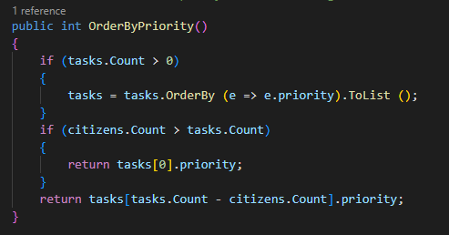The OrderByPriority function sorts the list by order of priority to find which task in the list has the lowest priority to be assigned based upon the number of citizens and tasks and returns it as value X.

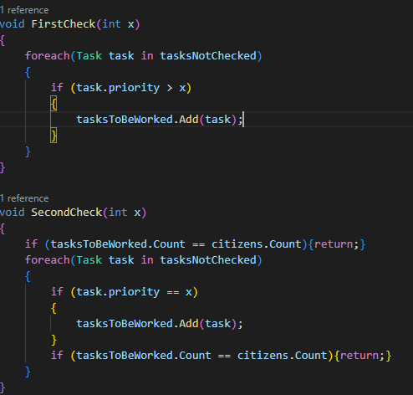Then the first check looks though the tasks list for any task with a prioity greater than X and adds it to the tasksToBeWorked list, the second check looks though the list again, this time looking for every task with a prioirty value matching x and adding it to the before metioned list until the citizen count matches the tasksToBeWorked list’s count.

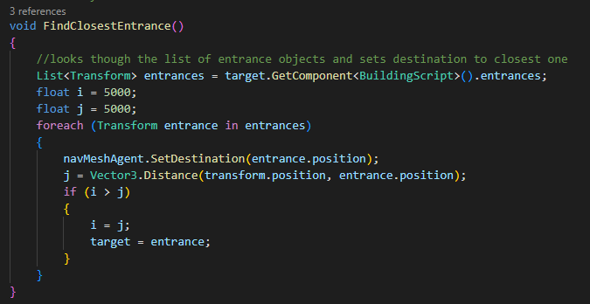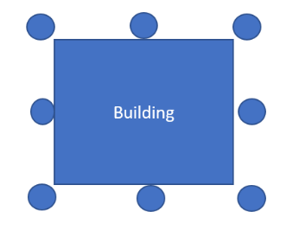The FindClosestEntrance function is used by each citizen when it’s got a job to find the closest entrance to itself, this prevents the citizen from wandering around the building unnecessarily. The circles in the below illustration represent the entrances mentioned, the corner ones aren’t pathfinded to but are still there to prevent the agent becoming stuck when navigating to a blocked entrance.

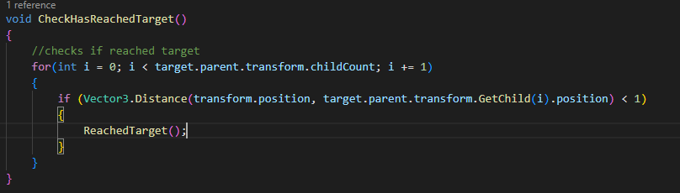This is the code used for detecting if the entrance has been reached, it checks the distance to each entrance and runs the ReachedTarget Function if one is lower than 1.

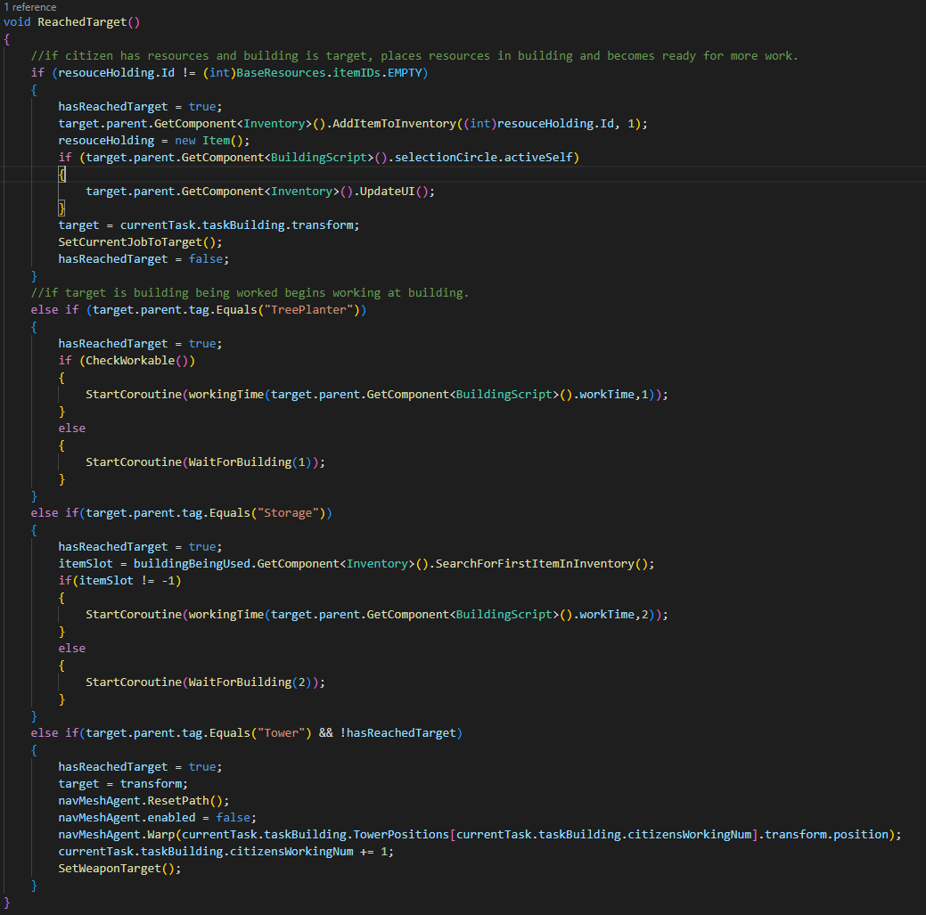This is the code that runs from the previous function mentioned, it handles how a citizen behaves when it reaches the building, first it checks if the citizen is holding a item, in which case the code assumes it is dropping it of at the building which should always be the case unless something went wrong.

The code then checks if the building reached is a tree planter and if a tree is ready, if so, it begins to work and gather wood, if a tree is not ready it waits until one is and proceeds to collect wood from it.

Then the code checks if it’s a storage building and collects an item from it if there is one available otherwise it waits until one is.

Finally, it checks if the building reached is a tower building and if so climbs on top and prepares to attack any nearby enemies.

Discussion

How the implementation effected the behaviour of the system and a judgment of how successful this is at achieving the desired behaviour

My primary goal was to make the managemnt of your civilation as easy as possible, but with the ability to fine tune if so desired and once set up the ability to reprioitize things with the click of a few buttons, I belive I have acumplished this goal. I have done this by having a prioity system, this is so if there is a shortage of a resource or a large wave of emimies is approching, the citizens can be reassigned quickly. Each building is also designed in such a way that each job is applied by hand, so the base can be optimized by a clever player if they so desire. However its not perfect, at the minute there is no way to assign a specific number of citizens to a specific task and each task type will always have the same priority, so if there are two tower buildings as part of a defence group, the citizens won’t properly divide between both of them equally unless specifically set up to do so before hand.

Another goal was to prioritize the action of the game and I belive ive done that, as once things are set up you can leave the base to explore or fight enimies and the base will take care of itself, if there’s an attack you can reprioritize citizens on defence remotely without needing to be there yourself. However there is still improvement that could be made here as well, as there is no way to schedule certain actions under certain conditions, meaining you still have to handle things yourself.

I belive the performance goal has been met, especially with my clever task asigner code implemented, to minimize the times the tasks list needs to be searched.

2. Clear understanding of how the approach taken influenced the feasibility of implementation and the runtime requirements of the system

My approach to make the AI for this game has limited what I’ve been able to accomplish, as each time I’ve changed one thing its tended to have a knock-on effect. For example, when I added the tower building, the agent would run the update function which checked if it had reached the tower, then he would climb onto it and change a bool value of hasReachedTarget to true, which should have prevented the check of reached target from running, what I didn’t know which took two days of trying things, was that the update function doesn’t wait for the functions its called to finish running before running again, as such it was calling the function ReachedTarget multiple times instead of just once.

Also the job system took longer that expected and a few iterations before the final design, as I needed a system that would allow each job to have different priorities configurable to the user, to make sure each citizen had only one job and didn’t switch unless it had to, and that it was efficient at handling potentially 1000+ citizens and 1000+ jobs without crashing.

As a result, things progressed slower than I would have liked, thus resulting in the citizen spawning and enemy spawning mechanics aren’t present but would have been with more time.

3. Clear understanding of alternative approaches

I believe I could have used a hierarchical state machine for the citizen ai, as that would have allowed for separate state machines for working, eating, sleeping, or wondering further improving how the citizens react when not having a job.

The enemies could make use of an evolutionary algorithm for deciding the attack angle, as for example if they attack from a direction and get wiped out quickly, then they will know there is where your defence is strong and will attempt to attack from another angle. This approach could also dictate their formations too, as they could learn which formation is most effective by trial and error, making the player have to keep adapting their strategy to stay ahead.